*Florida International University*

*School of Computing and Information Sciences*

Software Engineering Focus

Final Deliverable

**Officer Candidate Management System 2.0**

**Team Members: Hansini Seth (5794990) and Ishan Shrivastava (5792408)**

**Product Owner(s)**: **Tiago Moore**

**Mentor(s)**: **Tiago Moore and Mohsen Taheri**

**Instructor**: **Masoud Sadjadi and Francisco R. Ortega**

The MIT License (MIT)

Copyright (c) *2016 Florida International University*

Permission is hereby granted, free of charge, to any person obtaining a copy of this software and associated documentation files (the "Software"), to deal in the Software without restriction, including without limitation the rights to use, copy, modify, merge, publish, distribute, sublicense, and/or sell copies of the Software, and to permit persons to whom the Software is furnished to do so, subject to the following conditions:

The above copyright notice and this permission notice shall be included in all copies or substantial portions of the Software.

THE SOFTWARE IS PROVIDED "AS IS", WITHOUT WARRANTY OF ANY KIND, EXPRESS OR IMPLIED, INCLUDING BUT NOT LIMITED TO THE WARRANTIES OF MERCHANTABILITY, FITNESS FOR A PARTICULAR PURPOSE AND NONINFRINGEMENT. IN NO EVENT SHALL THE AUTHORS OR COPYRIGHT HOLDERS BE LIABLE FOR ANY CLAIM, DAMAGES OR OTHER LIABILITY, WHETHER IN AN ACTION OF CONTRACT, TORT OR OTHERWISE, ARISING FROM, OUT OF OR IN CONNECTION WITH THE SOFTWARE OR THE USE OR OTHER DEALINGS IN THE SOFTWARE.

***Abstract***

*This document presents the information necessary to gain a good understanding of Officer Candidate Management System. OCMS is a unique application which will allow officers and evaluating personnel to efficiently manage, rank, and evaluate new cadets and officer candidates in training. This tool will reduce the amount of paperwork done on a daily basis, and will allow for a smooth experience students training as officer candidates in the military. This is a unique application that is critically needed throughout many detachments in the country.*

**Table of Contents**

**Introduction**

Current System …………………………………………………………………….…………………5 Purpose of New System……………………………………………………………………………….5

**User Stories**

Implemented User Stories …………………………………………………………………………..6

Pending User Stories …………………………………………………………………………………8

**Project Plan**

Hardware and Software RESOURCES …………………………………………………………....9

Sprints Plan

*Sprint 1* ……………………………………………………………………………………….... ……9

*Sprint 2* …………………………………………………………………………………….... ………9

*Sprint 3* ……………………………………………………………………………………... ……...10

*Sprint 4* ………………………………………………………………………………………….......11

*Sprint 5* ………………………………………………………………………………………….......12

*Sprint 6* ………………………………………………………………………………………….......13

*Sprint 7* ………………………………………………………………………………………….......14

**System Design**

Architectural Patterns …………………………………………………………………………...15

System and Subsystem Decomposition…………………………………………………………...16

Deployment Diagram ……………………………………………………………………………… 17

Design Patterns……………………………………………………………………………….……..19

**System Validation** ……………………………………………………………………………………19

**Glossary** ………………………………………………………………………………………………..25

**Appendix A**

Appendix A - UML Diagrams…………………………………………………………………….……. 26

*Static UML Diagrams*……………………………………………………………………………….26

*Dynamic UML Diagram* ……………………………………………………………………..……..34

Appendix B - User Interface Design ……………………………………………………………… 54

Appendix C - Sprint Review Reports ……………………….……………………………………...67

Appendix D - User Manuals, Installation/Maintenance Document, Shortcomings/Wish list Document and other documents…………………………………………………………….70

**REFERENCES**…………………………………………………………….……………...…….74

**INTRODUCTION**

OCMS is an application which allows officers and evaluating personnel to efficiently manage, rank, and evaluate new cadets and officer candidates in training. This application will reduce the amount of paperwork done on a daily basis, and will allow for a smooth experience for students training as officer candidates in the military. This is a unique application that is critically needed throughout many detachments in the country.

## Current System

The OCMS 2.0 current system allows any user to register into the system with credentials like

Name, email id, phone number, rank, academic year etc. The user can login with their roles like supervisor or student. If the user is Student, he/she can login with their username and password. Then they can mark their attendance on the attendance sheet. This attendance will be recorded with date, time and location (IP address) so that the supervisor may know whether it is fake attendance or not. On the other hand if the user is Supervisor, he/she can login with username and password. He can view the date and time of the student who has marked the attendance. On the other hand, both the users can upload their profile picture. In this way, the application will allow feasibility to the students and to the supervisor for better experience during their training. In this version of OCMS 2.0 we have also included an event page where the students can view the events and join them that is created by the supervisor.

## Purpose of New System

The purpose of making Officer Candidate Management System 2.0 is to reduce paperwork and save time and money with this attendance management system. Moreover it can eliminate duplicate data and fake attendance entries, Improve visibility to track and manage student attendance & absenteeism across multiple base locations, Track the attendance of teachers and staff, assign work and manage allocation. Besides this, we can keep the record of trainees shift during their sessions. Also based on their geographical locations we can detect whether they are making true attendance or not, with the help of IP address. The supervisor can keep a track record of student’s progress by involving their participation into events.

**USER STORIES**

The Officer Candidate Management System 2.0 used the agile process of Scrum for software development. This part of the document contains a comprehensive list of all the user stories gathered from the product owner. They are separated into implemented user stories that were completed and pending user stories to be carried over into the next version of the system.

## 

## Implemented User Stories

*User Story #161: Selection of Software Stack*

* As a developer, I would like to select the software stack first so that I would be able to work on the project.

*User Story #159: Redesigning: The Registration and Login Page*

* As a user, I want to view more user friendly registration and login page so that I am able to access it without any difficulty.

*User Story #160: Redesigning: The Supervisor and Student Login Page*

* As a user, I want to view more attractive Login page so that I am able to access it without any difficulty*.*

*User Story #168: Creating an Event Page for Supervisor*

* As a supervisor, I would like to add new events in the event page so that each student can register for the events.

*User Story #171: Displaying the Event Page on Student Login.*

* As a user, I want to view all the events listed by the supervisor so that I can sign up for the event and the supervisor can see my name.

*User Story #180: Customizing the Appearance.*

* As a user, I want to view more convenient and user friendly website so that I can access all the features of the website easily.

*User Story #181: User Profile Image.*

* As a user, I want to upload my profile image so that my account looks more attractive.

*User Story #184: List of students enrolled for an**event.*

* As a Supervisor, I want to view all the students who have applied for the events so that I can make a note of all the registered events and students.

*User Story #185: Apply for an Event.*

* As a student, I want to apply for an event which the supervisor has created, so that I can participate in the event and supervisor gets notified for it.

*User Story #188: Marking of Location.*

* As a user, I would like to mark my attendance with respect to my location, so that the supervisor would know where actually I am present.

# Pending user stories

*User Story #151: Working of AWS functionality.*

* As developer, I would like to deploy my website to AWS server so that it can be accessible to everyone and from anywhere in the world.

**PROJECT PLAN**

The Officer Candidate Management System 2.0 was the second iteration of this project, so the first sprints were dedicated to the change in setup; design and selecting the better software stack for the system. The registration, login, attendance features functionality were developed concurrently by starting on the second sprint. There were changes made to all the ongoing stories and the original requirements, which were handled according to agile methodology.

Some of the changes were the design of the entire project, modifications in the profile page. Moreover, few features were added like events page, location of student while marking the attendance. The entire tasks were completed on time.

## Hardware and Software Resources

The following is a list of all hardware and software resources that were used in this project:

Operating System: Windows; mutually agreed by Product Owner and the Team Members.

Server: XAMPP Server; mutually agreed by Product Owner and the Team Members.

Database: Phpmyadmin; mutually agreed by Product Owner and the Team Members.

Application Logic: PHP, HTML5, CSS, JAVASCRIPT.

Mingle, GitHub, Google Drive.

**Sprint Planning**

### Sprint 1(01/16/2017-01/27/2017)

*Tasks*

* The entire project should be completed on the same software stack.
* Created a Video presentation: [https://www.youtube.com/watch?v=kj7ZddynWrQ&amp;feature=youtu.be&amp;hd=1](https://www.youtube.com/watch?v=kj7ZddynWrQ&feature=youtu.be&hd=1)
* Once the deployment should done,
* website is tested properly.

### Acceptance Criteria

* The software stack should fulfill the project requirements.
* The software stack should include front-end, back-end, server, operating system.
* The application should be a working condition.
* The application should be without any error and bugs.

**Sprint 2(01/30/2017-02/10/2017)**

*Tasks*

* The appearance should be very nice, attractive and friendly.
* The link for the video:  
  [https://www.youtube.com/watch?v=kj7ZddynWrQ&amp;feature=youtu.be&amp;hd=1](https://www.youtube.com/watch?v=kj7ZddynWrQ&feature=youtu.be&hd=1)
* The supervisor and student pages should be convenient and attractive.

### Acceptance Criteria

* There should be more customization using CSS property.
* Apply border and shades to the page.
* Add drop down feature.
* Use of bootstrap technique.
* The page can have a picture or any image.
* Create video for sprint 1and 2.
* Use of bootstrap technique.
* The login page should have border and shades.
* There should be a sidebar on the home pages of student and supervisor which shows profile, attendance and events option.

### Sprint 3(02/13//2017-02/24/2017)

*Tasks*

* All the students must be registered and should be able to view the list of events.
* Create a demonstration video.  
  <https://www.youtube.com/watch?v=wJ3ym520j74&feature=youtu.be&hd=1>
* Students should be able to see the list of all events.

*Acceptance Criteria*

* There should be an option to add new events.
* All the added events should be displayed to the students account.
* The user should be registered to the system.
* The event should display the title, location, time and description.

***Sprint 4(02/27/2017-03/10/2017)***

*Tasks*

* The application should be attractive, secure and easy to use.
* Created a demonstration video:
* <https://www.youtube.com/watch?v=mRFQNy93AfQ&feature=youtu.be&hd=1>
* Created a feature document: <https://docs.google.com/document/d/1KhGAoNC0HCmMh2EVLszO-5y_HC8ybUHqVi0rQ4WLRAw/edit>
* Completed testing.
* The image can be of any dimensions.
* The user can select image from any computer, laptop etc.

*Acceptance Criteria*

* The design should be changed.
* There should be navigation bar and side bar as required for the design.
* Bootstrap technique can be used.
* There should be a option to select the image from the computer.
* There should be a option to upload the image.
* The image should be there until and unless the user changes it.
* The image should come with user profile details.

### Sprint 5(03/20//2017-03/24/2017)

*Tasks*

* Created a video demonstration: <https://www.youtube.com/watch?v=2aw9XRG_278&feature=youtu.be&hd=1>
* Created Feature document: <https://docs.google.com/document/d/149ZR471A3GVVK0P_pa0seiDGwA0eHF2_lPyqCabw1Q8/edit>
* Completed testing.

*Acceptance Criteria*

* Supervisor must be registered into the system.
* Supervisor must create new events for students to register.
* Supervisor must give an option for students to join the events.
* Student should be registered into the system.
* Student should be able to see the list of events created by the supervisor.
* There should be an option for students to apply for the event.

***Sprint 6(03/27/2017-04/07/2017)***

*Tasks*

* Created a video demonstration: <https://www.youtube.com/watch?v=etvg-lTkyKw&feature=youtu.be&hd=1>
* Created Feature document: <https://docs.google.com/document/d/1mFrei6VqEmpjb9H64l3pk-9YrDs6jPRN62_7nLI3Etw/edit>
* Completed testing.

*Acceptance Criteria*

* Use of IP address can be considered.
* Supervisor would be able to cross-check it.
* It should inform the location of the student through internet.
* There should be proper boxes around the list of display events.
* There should be attributes for attendance sheet as well as boxes around the data.
* The title should be more attractive and visible.

### Sprint 7(04/10/2017-04/21/2017)

*Tasks*

* Wrapping Up.
* Working on Presentation, Poster and Final Document.

### Sprint 8(04/24/2017-04/28/201)

*Tasks*

* Final Deliverables.

**SYSTEM DESIGN**

This section contains information on the design decisions that went into this project. The architecture patterns are outlined and explained. The entire system is shown in a package diagram and the subsystems are explained. Finally, the design patterns used in the project are discussed.

## Architectural Patterns

The Officer Candidate management system 2.0 uses 3Tier architecture. The Officer Candidate management system 2.0 queries a lot of information from the database and the 3tier architecture allows for a protection from any potential misuse of the system due to the interface and never making direct calls to the database. This architecture was perfect for a group project because since the tiers aren't connected it allows for different people to be working in a different tier at the same time. Most importantly if one tier fails no data is lost which is extremely important when dealing with user information.

## System and Subsystem Decomposition

The Officer Candidate management system 2.0 is composed of two subsystems, one for supervisor and one for student, which are the two actors of the system. The supervisor will see the list of the students who have marked their attendance with date, time and location. The student subsystem consists of marking the student, to make his/her presence to be known. The two subsystems are somewhat independent, except for student. The attendance feature will only work when student marks his/her presence, so that the supervisor can see it. It will also use the IP address of the server from where the student marks the attendance and in this way supervisor can track the student’s presence. There is also an event page introduced in this version where the students can join any event that is created by the supervisor. The supervisor would be able to view the number of students joined the event.

## C:\Users\HONEY\Downloads\WhatsApp Image 2016-11-28 at 10.28.24 PM.jpeg

## Deployment Diagram

The figure below describes the deployment diagram. It is followed with the MVC architecture pattern which is View, Model and Controller. This follows the general subsystems of the package diagram. In the view layer the system consists of the pages and views displayed to the client/user. The model layer uses MySQL on the server side. And the browser is responsible for the functionality.

C:\Users\HONEY\Downloads\systemdesign.png

**Design Patterns**

The design pattern used in the overall development of the system was the Model View Controller Pattern (MVC). This model is selected due to similarity with 3-tier architecture.

The MVC pattern is great for group projects because of the ability for different members of the project to be simultaneously working on the project without worrying about interdependency issues. The pattern also allows for multiple user interfaces using the same business logic to allow for future development on phones, tablets, etc.

**SYSTEM VALIDATION**

This part will introduce all of the test cases done during the development of the system. Unit and Subsystem tests were done with satisfactory results.

**User Story #162 Customize the Registration Page**

Unit Testing and Integration Testing:

Title: Customize the Registration Page

Description: A user would be able to see a more interactive registration page with validation.

Precondition: The user must have username, email id, school, rank, password, year and phone number to register.

Assumption: A supported browser is being used to view the website.

Test Steps:

1. Navigate to the website.
2. In the registration page, enter the username, email id, school, rank, password, year and phone number to register.
3. Click the ‘register’ button.
4. The home page will be opened.
5. Click ‘Logout’.

Expected Result: A Successful Registration.

**User Story #159** Redesigning the Registration and Login Page

Unit Testing and Integration Testing:

Title: Redesigning the Registration and Login Page

Description: A user would be able to see a more interactive registration and login page.

Precondition: The user must have username, email id, school, rank, password, year and phone number to register.

Assumption: A supported browser is being used to view the website.

Test Steps:

1.      Navigate to the website.

2.      In the registration page, enter the username, email id, school, rank, role, password, year and phone number to register.

3.      Click the ‘register’ button to register and ‘login’ button to login.

4.      The home page will be opened.

5.      Click ‘Logout’.

Expected Result:  A Successful Registration and Login.

**User Story #160** Redesigning: The Supervisor and Student Login Page

Unit Testing and Integration Testing:

Title: Redesigning the Registration and Login Page

Description: A user would be able to see a more interactive login and registration page.

Precondition: The user must have username, email id, school, rank, password, year and phone number to register.

Assumption: A supported browser is being used to view the website.

Test Steps:

1.      Navigate to the website.

2.      In the registration page, enter the username, email id, school, rank, role,password, year and phone number to register. In login page, enter the username and password.

3.      Click the ‘register’ button or ‘login’ button.

4.      The home page will be opened.

5.      Click ‘Logout’.

Expected Result:  A Successful Registration and Login.

**User Story #168** Creating an Event page for the Supervisor.

Title: Creating an event page for the supervisor.

Description: A registered supervisor can login and then can add new events.

Precondition: The user must have username, email id, school, rank, password, year and phone number to register. Also, he should have the list of events to add.

Assumption: A supported browser is being used to view the website.

Test Steps:

1.      Navigate to the website.

2.      In the registration page, enter the username, email id, school, rank, role,password, year and phone number to register. In login page, enter the username and password.

3.      After successful login, the supervisor can create new events by giving the description, title, location and time of the event.

4.      The home page will be continued after creating the event.

5.      Click ‘Logout’.

Expected Result:  A Successful creation of event.

**User Story #171** Displaying an Event page for the Student

Title: Displaying an event page for the student.

Description: A registered student can login and then can view new events.

Precondition: The user must have username, email id, school, rank, password, year and phone number to register. Also, he should have the login credentials to see the newly added events.

Assumption: A supported browser is being used to view the website.

Test Steps:

1.      Navigate to the website.

2.      In the registration page, enter the username, email id, school, rank, role, password, year and phone number to register. In login page, enter the username and password.

3.      After successful login, the student can view new events and their description, title, location and time of the event.

4.      The home page will be continued after viewing the event.

5.      Click ‘Logout’.

Expected Result:  A Successful viewing of event.

**User Story #182** Customizing the Appearance

Title: Customizing the appearance

Description:  A registered student can login and then can view more convenient and user friendly website.

Precondition: The user must have username, email id, school, rank, password, year and phone number to register. Also, he should have the login credentials to see the newly customised website.

Assumption: A supported browser is being used to view the website.

Test Steps:

1.      Navigate to the website.

2.      In the registration page, enter the username, email id, school, rank, role,password, year and phone number to register. In login page, enter the username and password.

3.      After successful login, the student can view new events and their description, title, location and time of the event.

4.      The home page will be continued after successful login with several options to access the functionality.

5.      Click ‘Logout’.

Expected Result:  Successful accessibility of customized features.

**User Story #183** Uploading profile picture.

Title: Uploading profile picture.

Description: A registered user can login and then can upload his/her profile picture.

Precondition: The user must have username, email id, school, rank, password, year and phone number to register.

Assumption: A supported browser is being used to view the website.

Test Steps:

1.      Navigate to the website.

2.      In the registration page, enter the username, email id, school, rank, role, password, year and phone number to register. In login page, enter the username and password.

3.      After successful login, the user should go to view profile.

4.      Once the user can view his profile, he can browse and upload profile picture by clicking on upload button.

5.      Click ‘Upload’.

Expected Result:  A Successful upload of profile picture.

**User Story** **#184** Display the list of students enrolled for an event.

Unit Testing and Integration Testing:

Title: Display the list of students enrolled for an event.

Description:  A registered supervisor can login and then can view the students enrolled for the events.

Precondition: The user must be registered to the system and should have applied for at-least one event.

Assumption: A supported browser is being used to view the website.

Test Steps:

1.      Navigate to the website.

2.      In the registration page, enter the username, email id, school, rank, role, password, year and phone number to register. In login page, enter the username and password.

3.      After successful login, the supervisor can view the list of events, their description and students registered in the event.

4.      The home page will be continued after successful viewing of this page.

5.      Click ‘Logout’.

Expected Result: Successfully displaying the list of students enrolled for an event.

**User Story #185** Apply for an Event

Unit Testing and Integration Testing:

Title: Apply for an event

Description:  A registered student can login and then can go to view events. From there he can see the list of events and can join them.

Precondition: The user must have username, email id, school, rank, password, and year and phone number to register. After successful login he can go to ‘join events’.

Assumption: A supported browser is being used to view the website.

Test Steps:

1.      Navigate to the website.

2.      In the registration page, enter the username, email id, school, rank, role, password, year and phone number to register. In login page, enter the username and password.

3.      After successful login, the student can view new events and their description, title, location and time of the event.

4.      The ‘Current events page’ will be displayed, where you can see the list of options and join them

5.      Click ‘Logout’.

Expected Result:  Successful apply for an event.

**User Story #188** Marking of Location.

Unit Testing and Integration Testing:

Title: Marking of Location

Description:  A registered student can login and then can go to give attendance. When he will give his signature for attendance, his name, date, time and IP will also be recorded.

Precondition: The user must have username, email id, school, rank, password, and year and phone number to register. After successful login he can go to give attendance.

Assumption: A supported browser is being used to view the website.

Test Steps:

1.      Navigate to the website.

2.      In the registration page, enter the username, email id, school, rank, role, password, year and phone number to register. In login page, enter the username and password.

3.      After successful login, the student can mark his attendance by typing his name as the signature.

4.      The ‘attendance page’ will be displayed, where he can mark the attendance and his location, name, date, time would get stored in the database.

5.      Click ‘Logout’.

Expected Result:  Successful marked attendance with location.

**User Story #188** Final Customization.

Unit Testing and Integration Testing:

Title: Final customization

Description:  A registered student can login and then can view better pages .

Precondition: The user must have username, email id, school, rank, password, and year and phone number to register. After successful login he can access all the features

Assumption: A supported browser is being used to view the website.

Test Steps:

1.      Navigate to the website.

2.      In the registration page, enter the username, email id, school, rank, role, password, year and phone number to register. In login page, enter the username and password.

3.      After successful login, the student can access attendance, events and profile features.

4.      User friendliness is improved for better accessibility of the application.

5.      Click ‘Logout’.

Expected Result:  Successful customization

**GLOSSARY**

Users: All the students and supervisor present in the academy during the training.

Deployment: launching the application on the web.

**APPENDIX**

# Appendix A - UML Diagrams

*Static UML Diagram (Class Diagram)*

Figure #1 User Story #162 Class Diagram

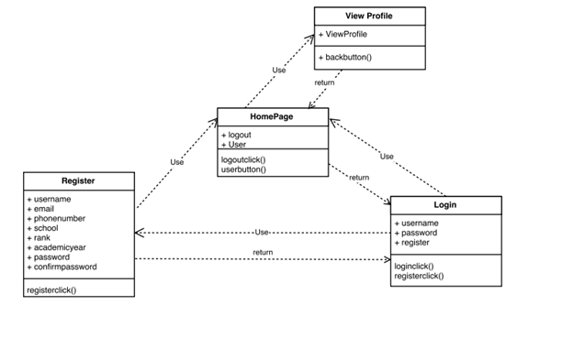

Figure #2 User Story #159 Class Diagram

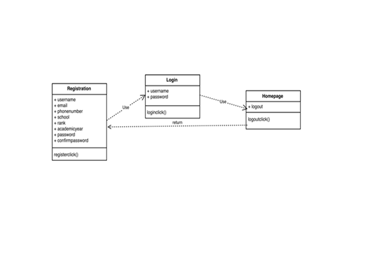

Figure #3 User Story #160 Class Diagram

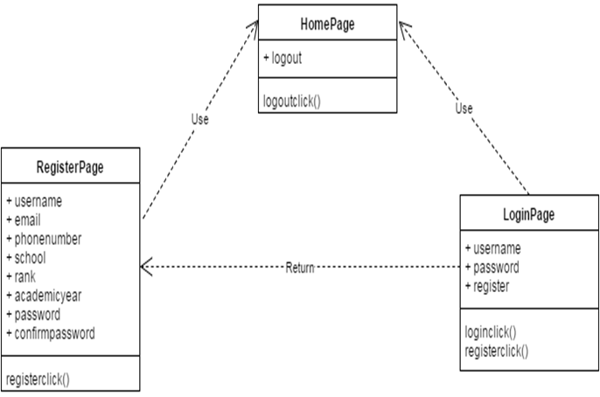

Figure #4 User Story #168 and #171 Class Diagram

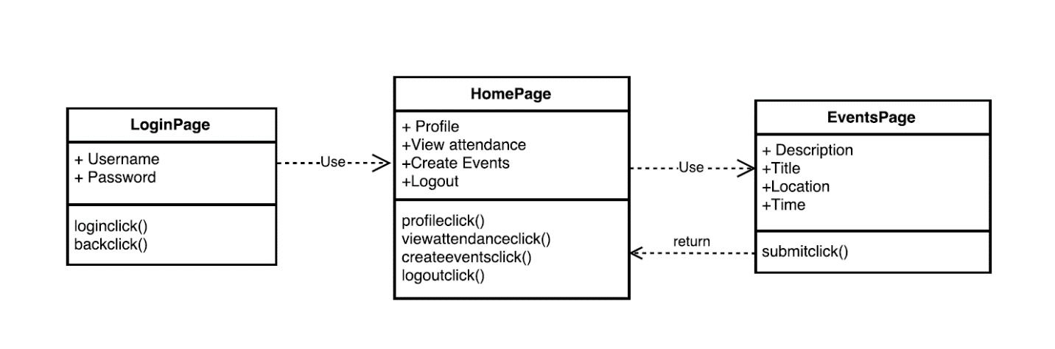

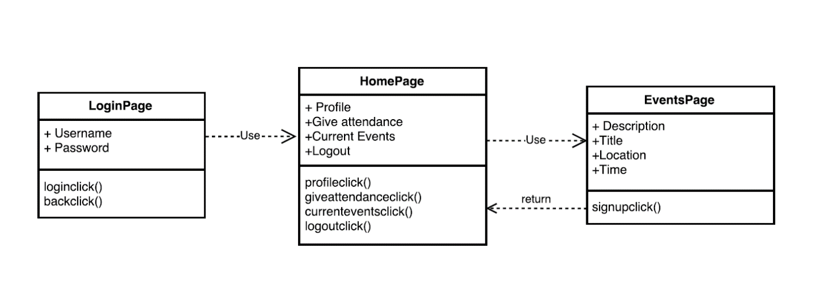

Figure #5 User Story #182 and #183 Class Diagram

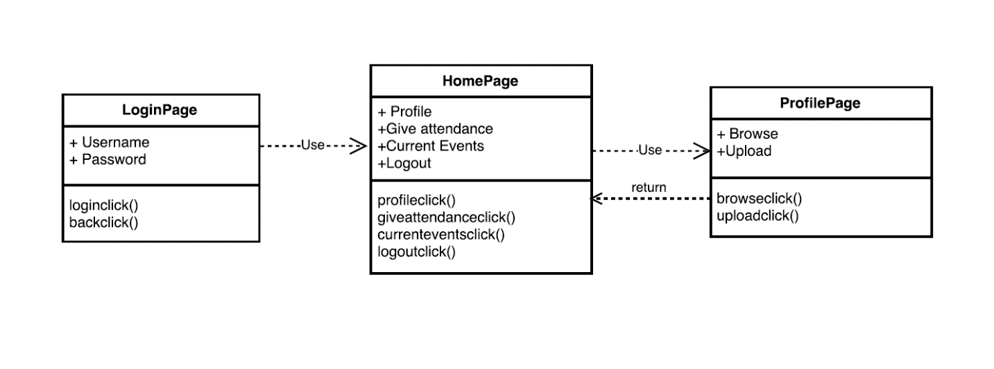



Figure #6 User Story #184 Class Diagram

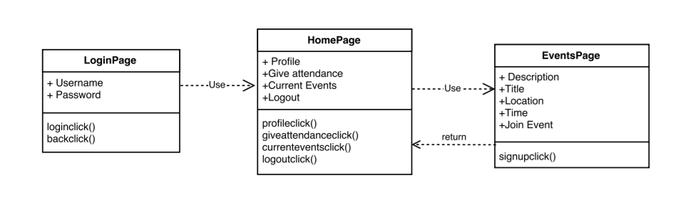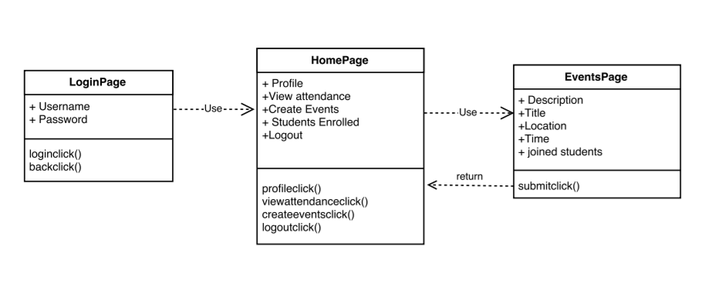

Figure #7 User Story #188 and #189 Class Diagram

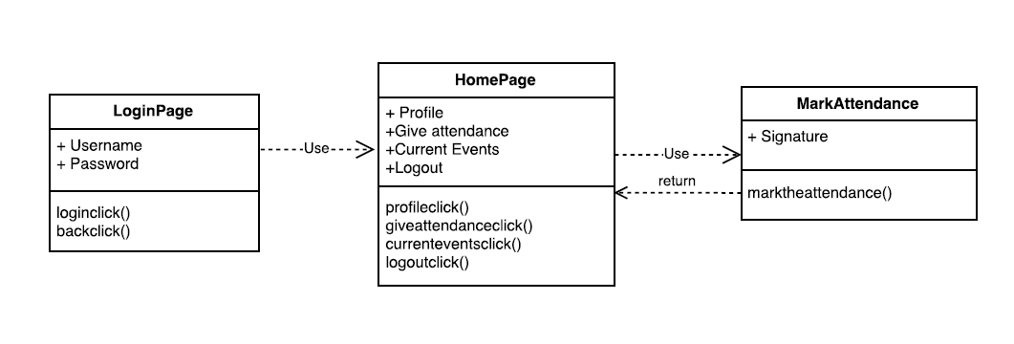



Figure #08 Object Diagram

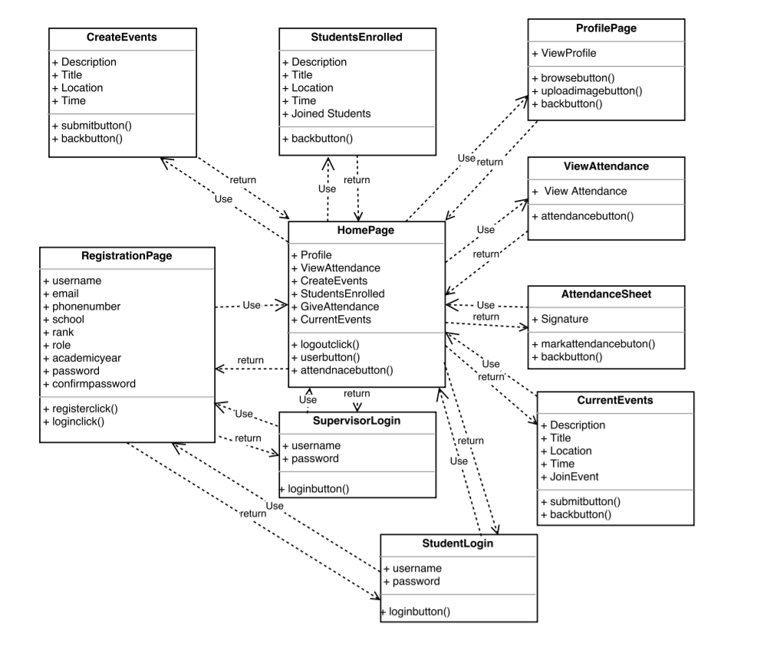

*Dynamic UML Diagram (Sequence Diagram)*

Figure #1 User Story #162 Sequence Diagram

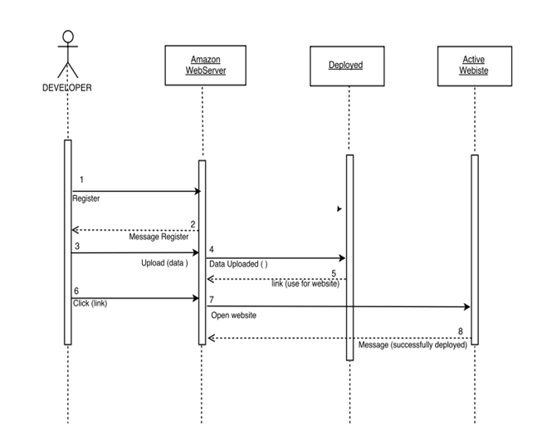

Figure #2 User Story #159 and #160 Sequence Diagram

## https://lh4.googleusercontent.com/dlA6bbZ3T5sttbXGJn3Dp6oLMWs_dBCs4hEcSAoepDdcihzuOBEwifmOeBAeLn1DUHf0EYJ0wLT-eLJoi51eTEa45XyDm12kvUzRFgNekws7TUc_-Nve9BeG_7UZyT0Ui339VPZ0

Figure #3 User Story #168 and #171 Sequence Diagram

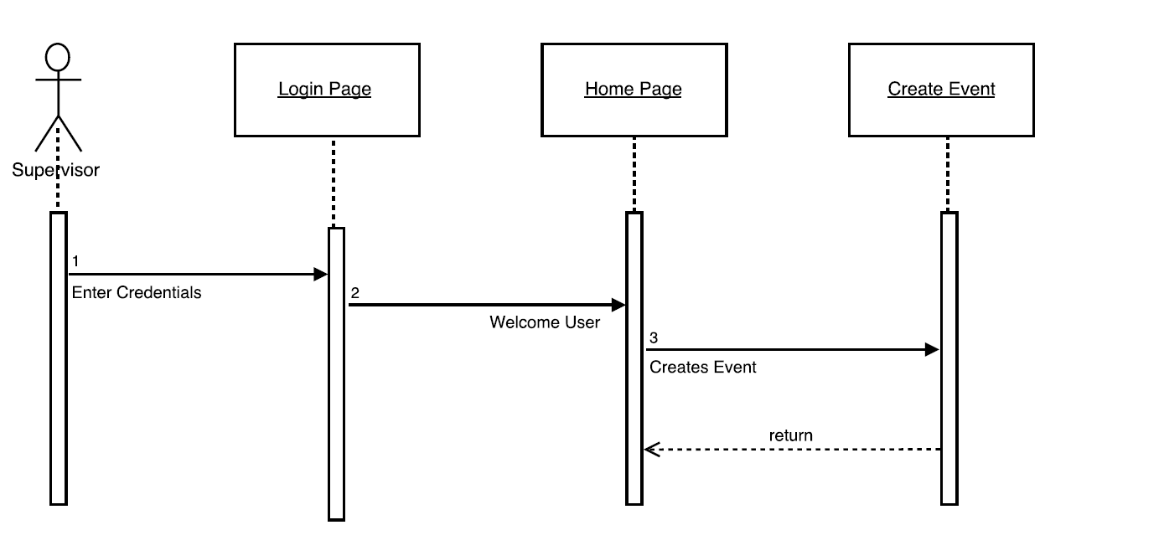

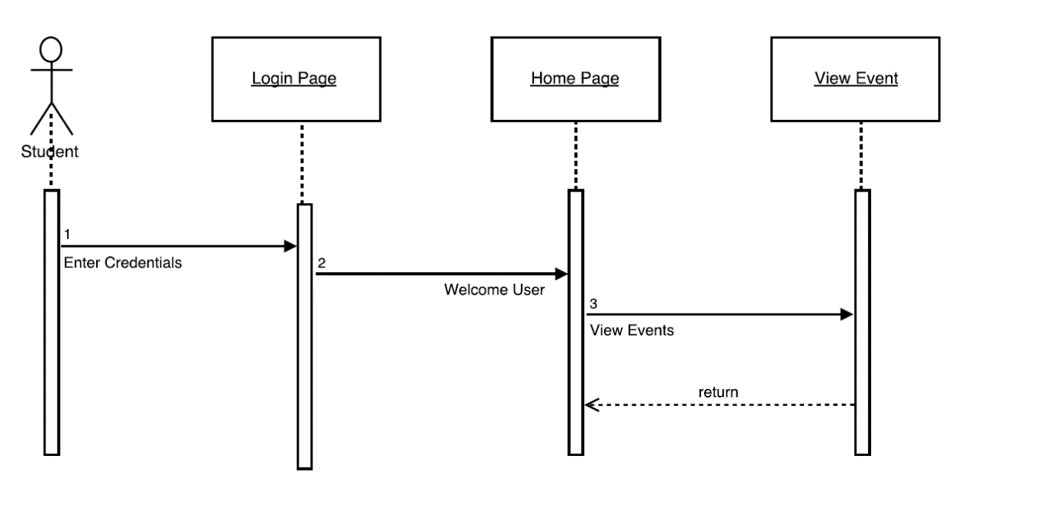

Figure #4 User Story #182 and #183 Sequence Diagram

SequenceDiagram.png

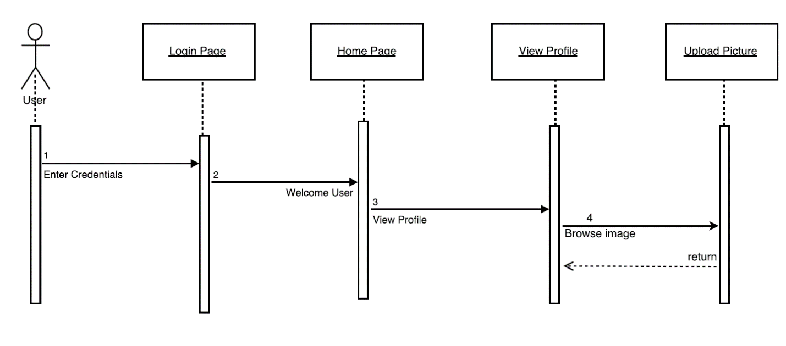

Figure #5 User Story #184 and #185 Sequence Diagram

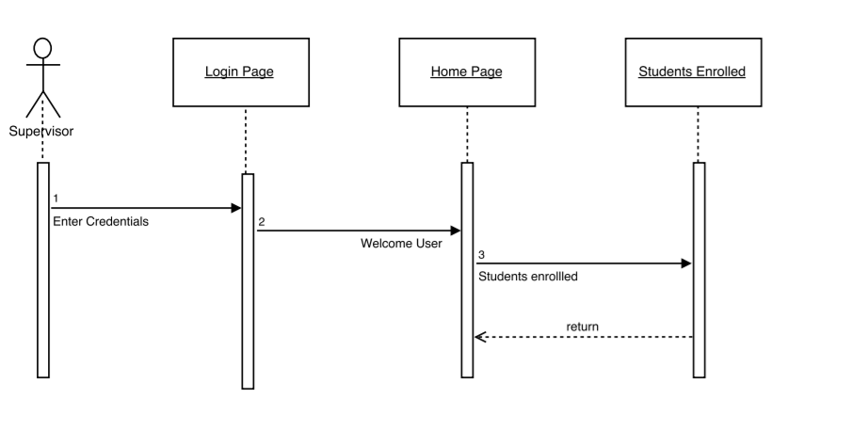

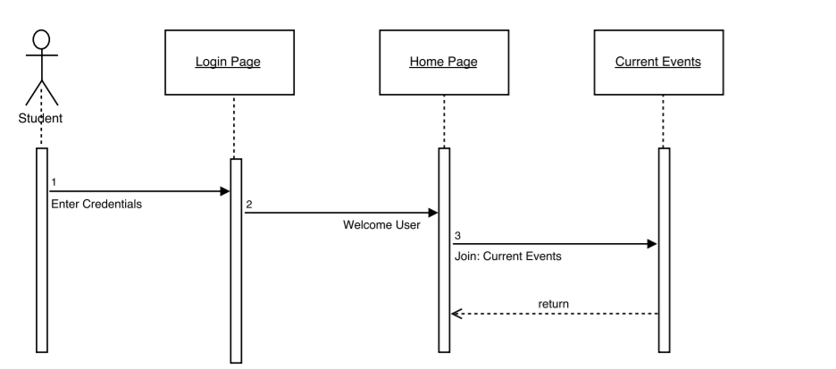

Figure #6 User Story #188 and #189 Sequence Diagram

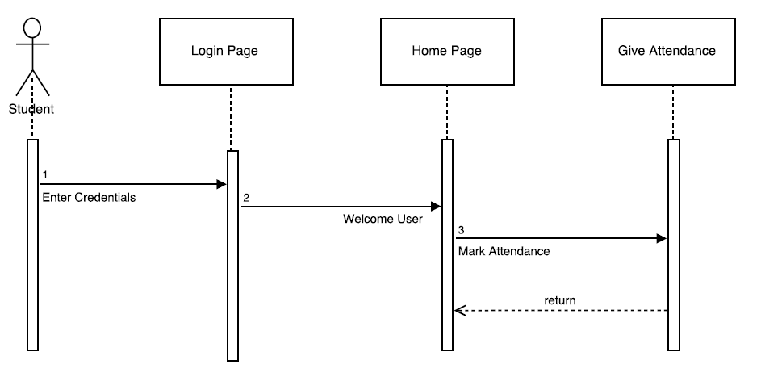

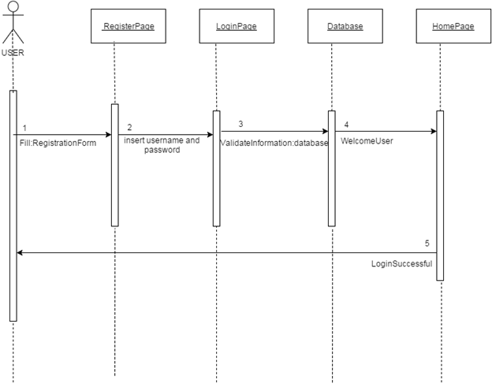

*UML Diagram (Use case Diagram)*

Figure #1 User Story #162 *Use case Diagram*

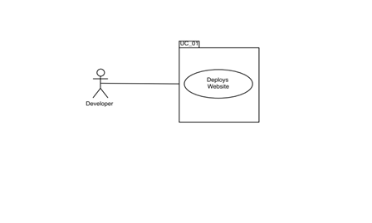

Figure #2 User Story #159 and #160 *Use case Diagram*

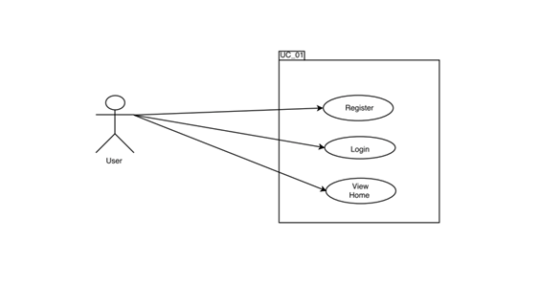 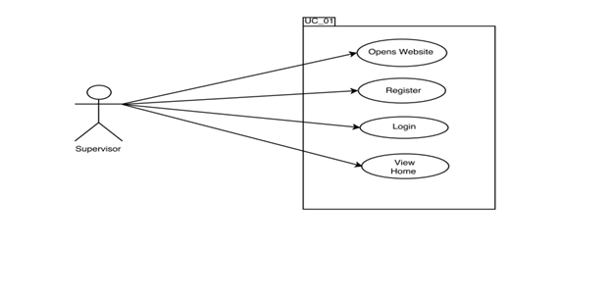 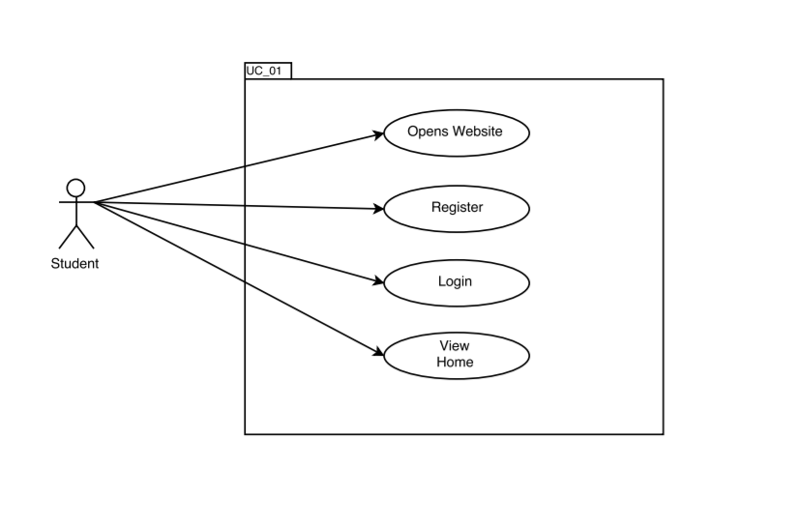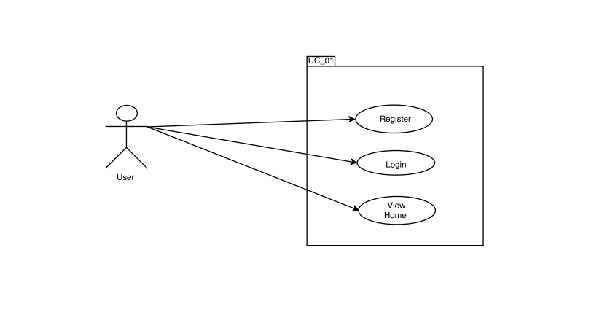

Figure #3 User Story #168 and #171 *Use case Diagram*

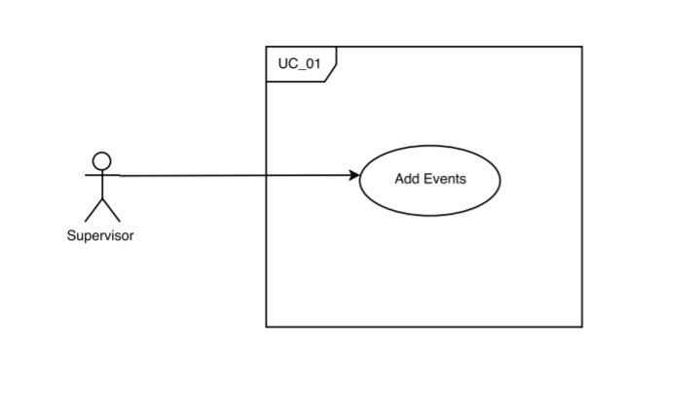

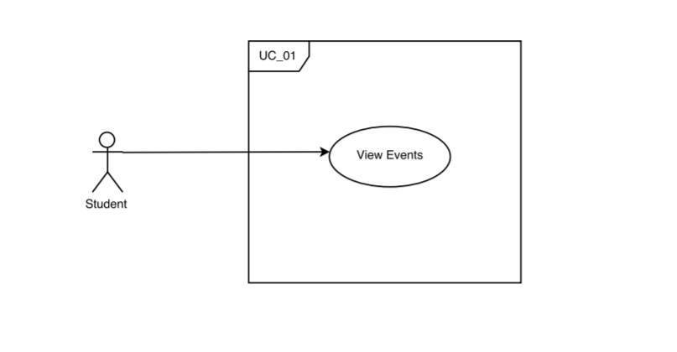

Figure #4 User Story #182 and #183 *Use case Diagram*



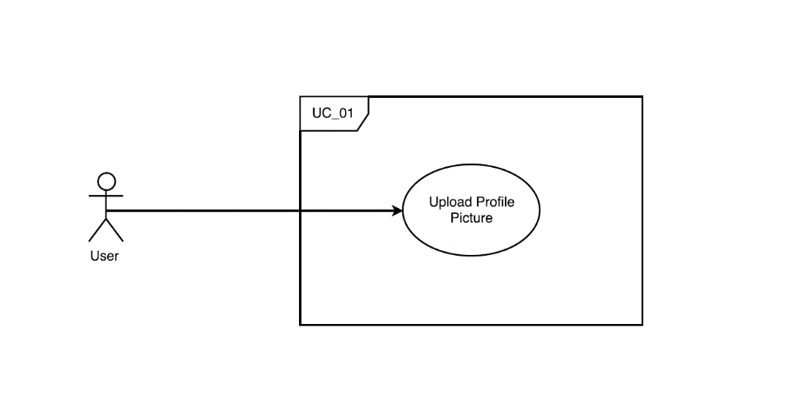

Figure #5 User Story #184 and #185 *Use case Diagram*

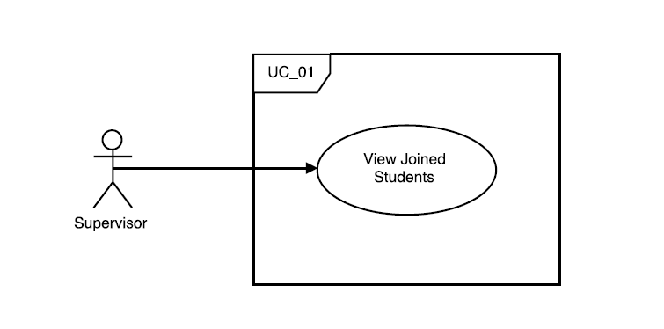

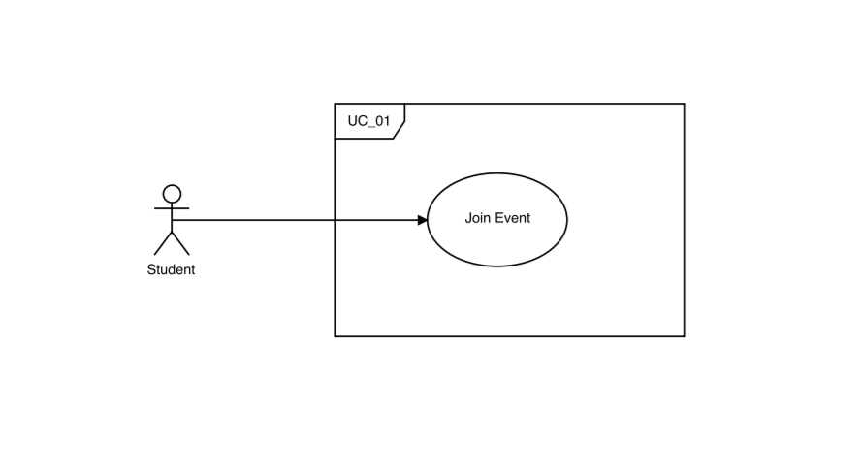

Figure #6 User Story #188 and #189 *Use case Diagram*

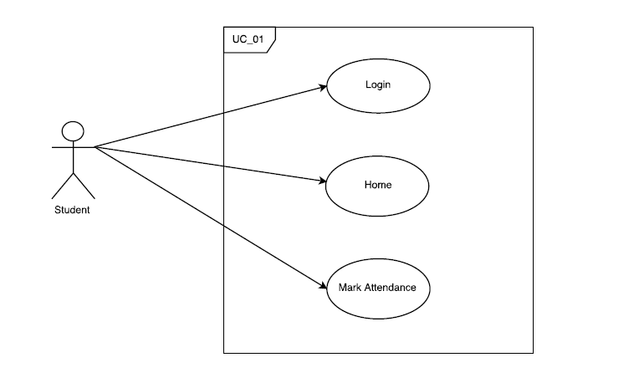





Figure #7 Whole project *Use case Diagram*

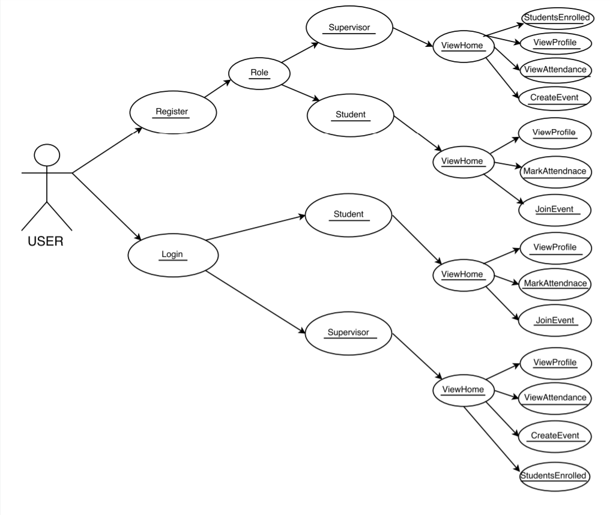

**Appendix B-User Interface Design**

*(Local Host)*

## Figure#1: Login Page

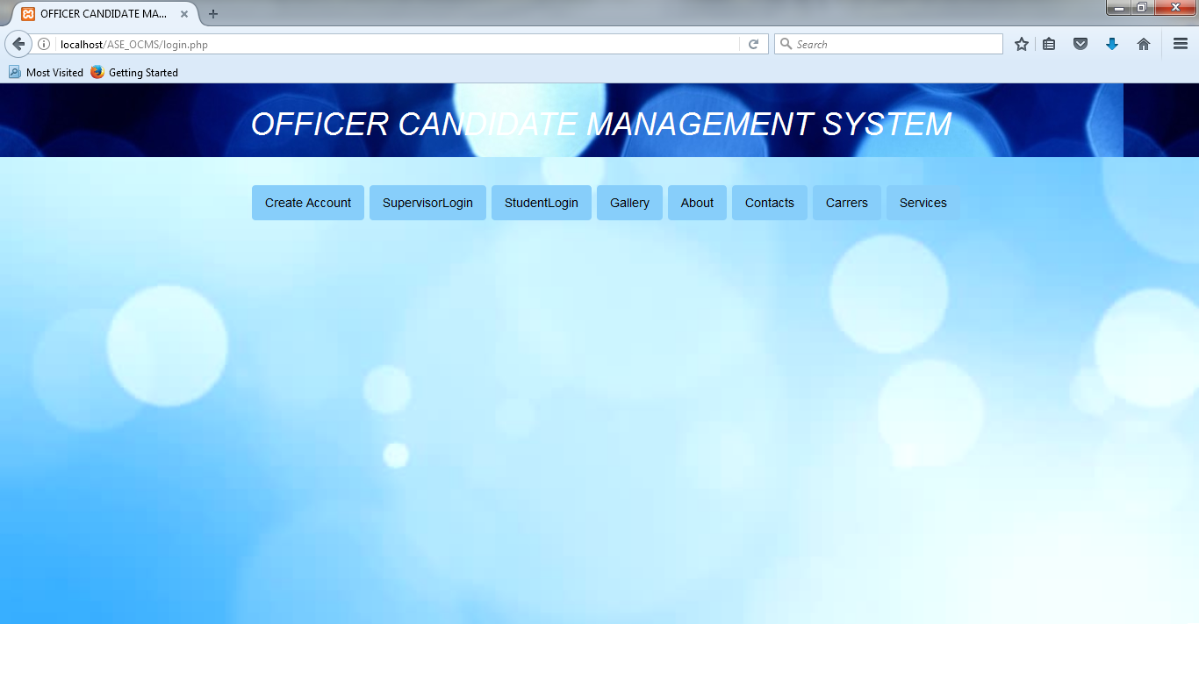

Figure#2: Register Page

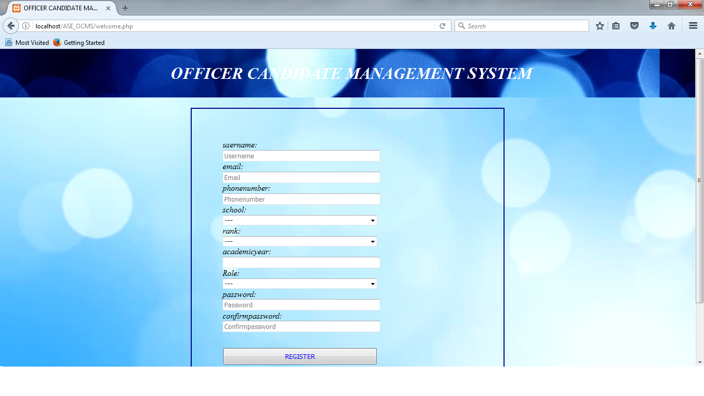

Figure#3: Supervisor Login Page

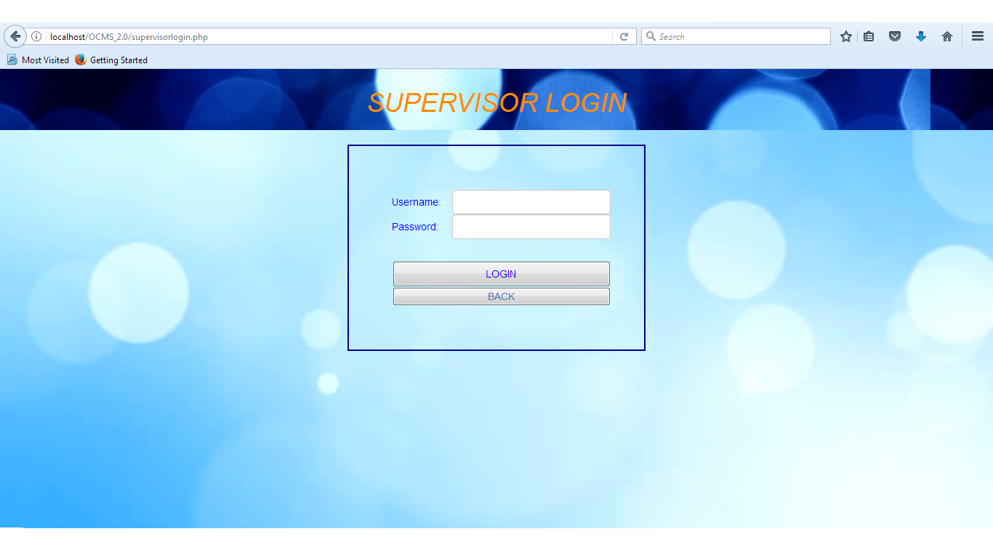

## Figure#4: Student Login Page

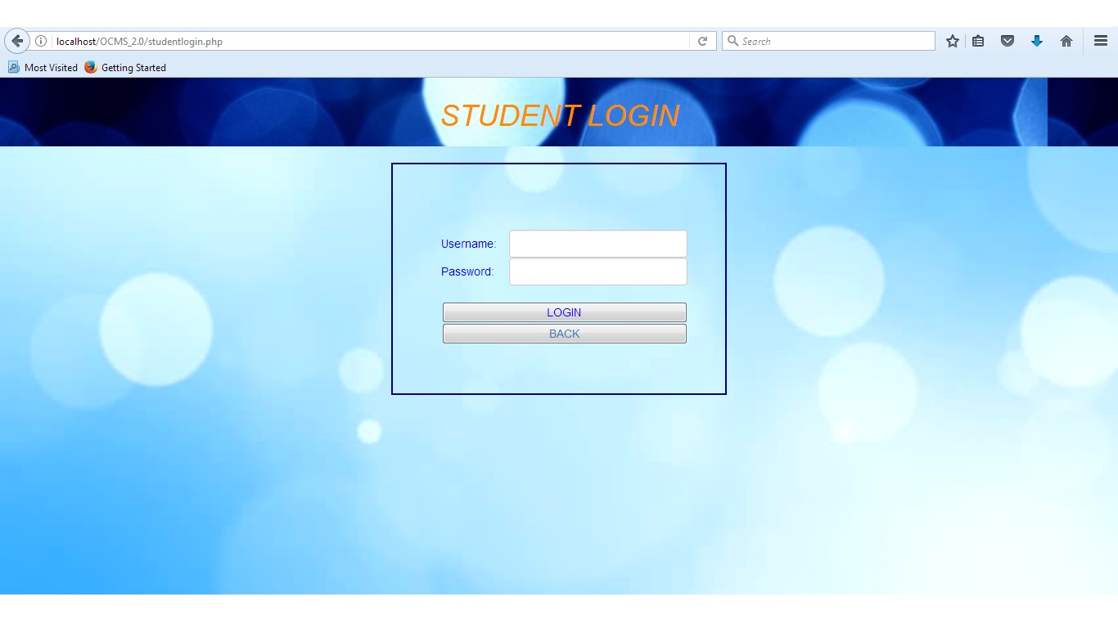

Figure#5: Attendance page for students

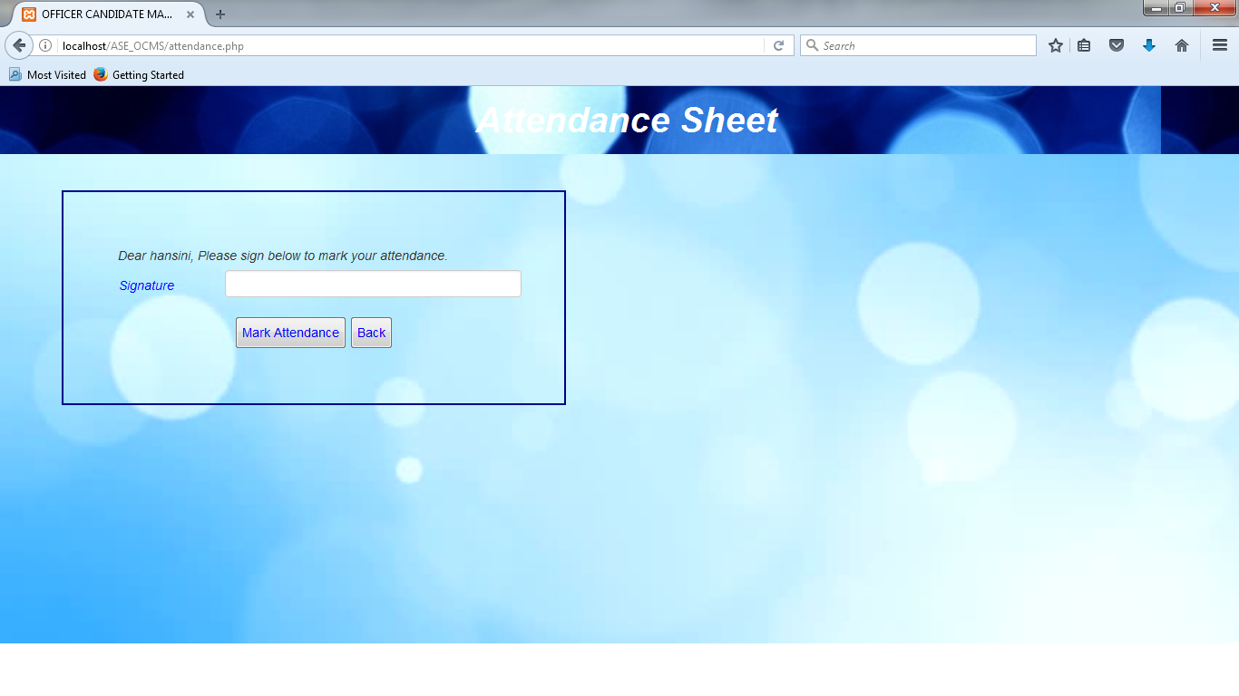

Figure#6: View Attendance page for supervisor

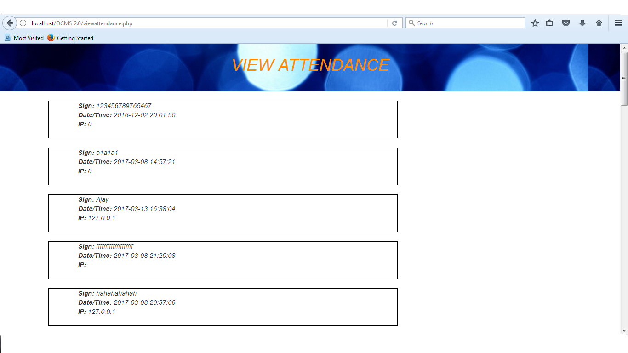

Figure#7: Profile Page

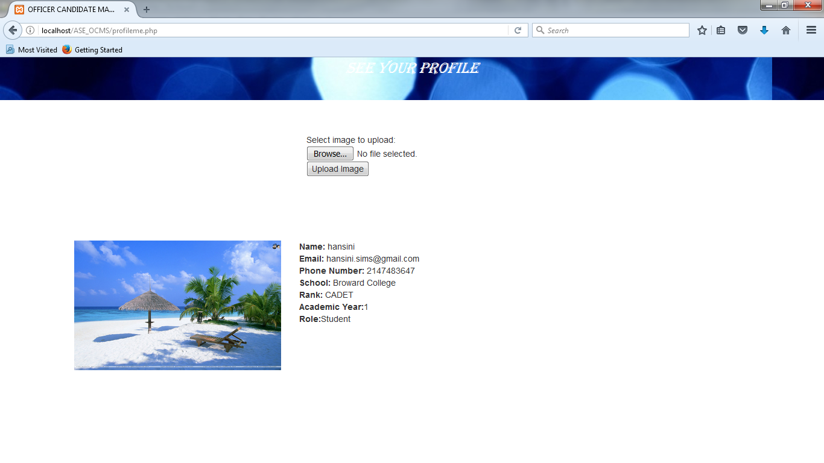

Figure#8: Home Page for Student.

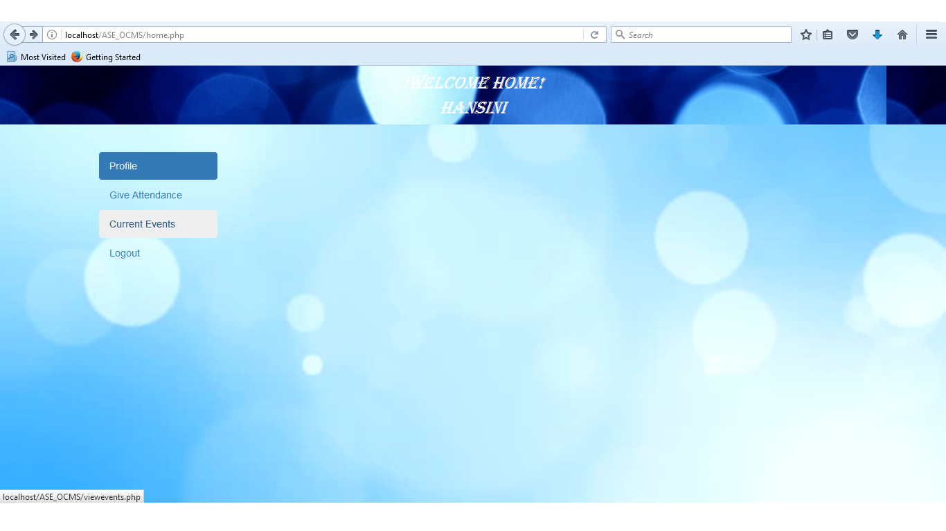

Figure#9: Home Page for Supervisor.

## 

Figure#10: Create Event Page for Supervisor.

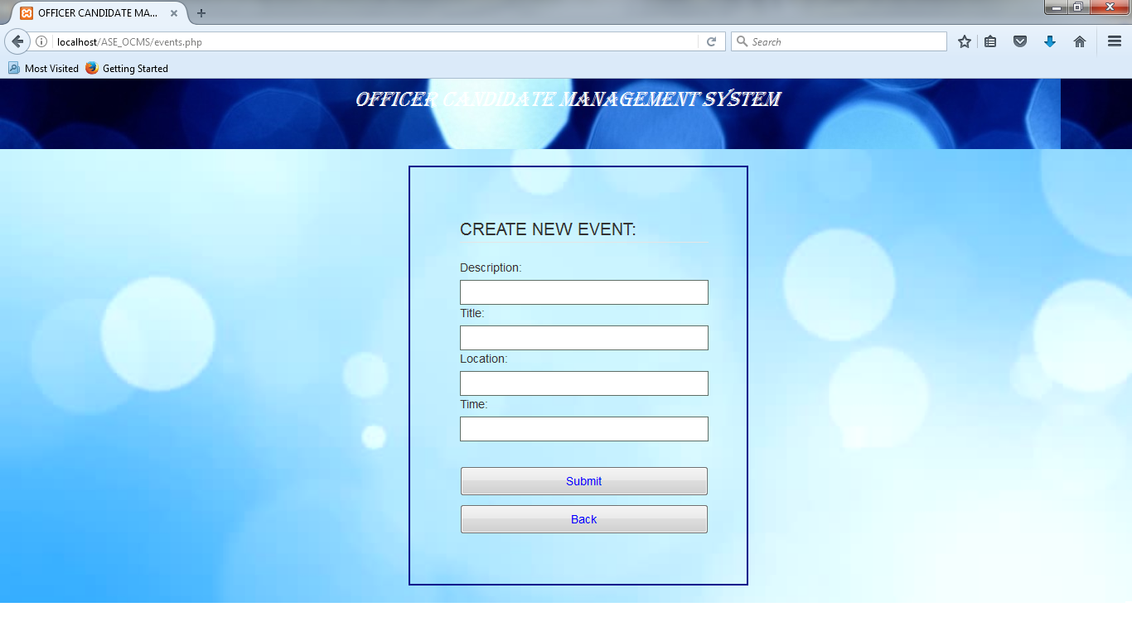

Figure#11: Join Event Page for Student.

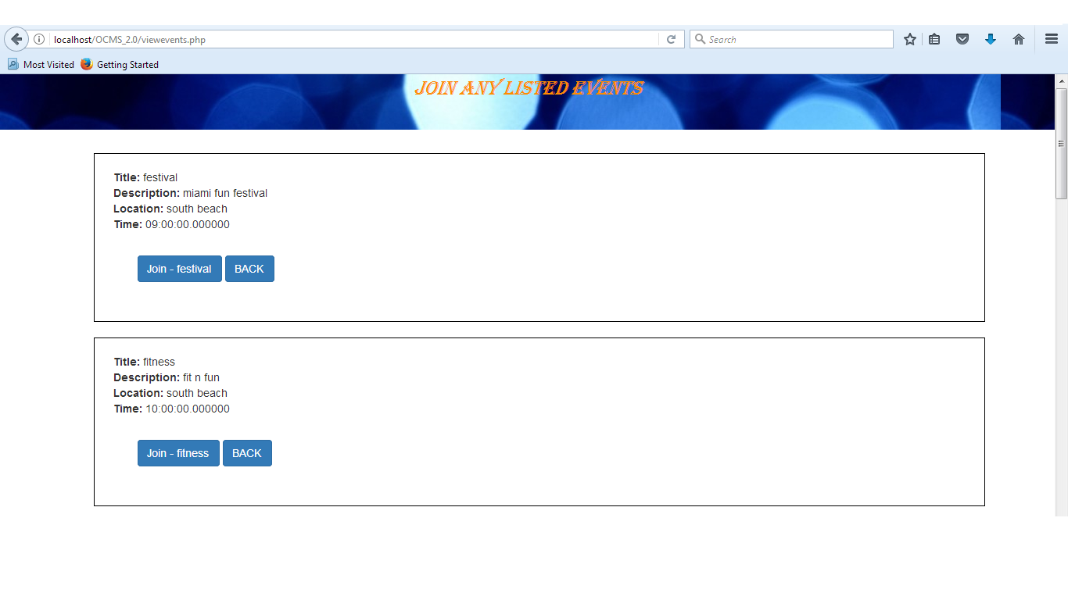

Figure#12: Students Enrolled Page for Supervisor.

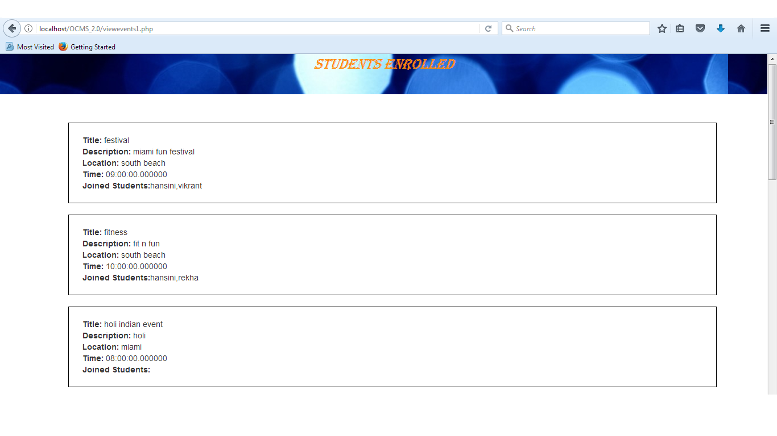

Figure#13: Database

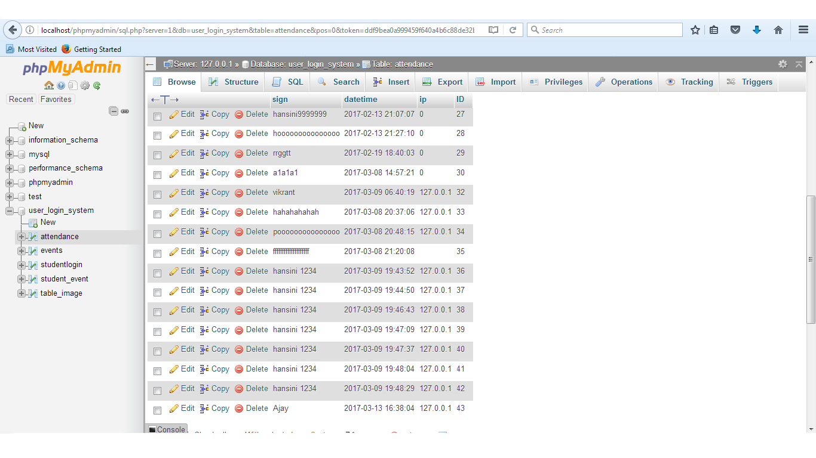

**APPENDIX-C SPRINT REPORTS**

**Sprint Review Meeting Minutes**

**Sprint 1:**

Attendees: <Hansini Seth and Ishan Shrivastava>

Start time: <14:20 p.m..>

End time: <15:00 p.m.>

After a show and tell presentation, the implementation of the following user stories were accepted by the product owners: All.

User Story 1: Selection of the software stack

The following ones were rejected and moved back to the product backlog to be assigned to a future sprint at a future Spring Planning meeting.

User Story 2: Working on AWS functionality : This user story has been moved to defect backlog.

**Sprint 2:**

Attendees: <Hansini Seth and Ishan Shrivastava>

Start time: <10:00 a.m.>

End time: <11:00 a.m.>

After a show and tell presentation, the implementation of the following user stories were accepted by the product owners: All.

User Story 3:Redesigning: The Registration and Login Page.

User Story 4:Redesigning: The supervisor and student Login Page

The following ones were rejected and moved back to the product backlog to be assigned to a future sprint at a future Spring Planning meeting: Nothing

**Sprint 3:**

Attendees: <Hansini Seth and Ishan Shrivastava>

Start time: 16:20 p.m.

End time: 17:00 p.m.

After a show and tell presentation, the implementation of the following user stories were accepted by the product owners: All.

User Story 5: Creating an Event Page for Supervisor

User Story 6: Displaying the Event Page on Student Login

The following ones were rejected and moved back to the product backlog to be assigned to a future sprint at a future Spring Planning meeting: Nothing

**Sprint 4:**

Attendees: <Hansini Seth and Ishan Shrivastava>

Start time: 18:00 p.m.

End time: 19:00 p.m.

After a show and tell presentation, the implementation of the following user stories were accepted by the product owners: All.

User Story 7: Creating a profile upload button for users.

User Story 8: Customize the attendance page for supervisor.

The following ones were rejected and moved back to the product backlog to be assigned to a future sprint at a future Spring Planning meeting: Nothing

**Sprint 5:**

Attendees: <Hansini Seth and Ishan Shrivastava>

Start time: 17:00 p.m.

End time: 18:00 p.m.

After a show and tell presentation, the implementation of the following user stories were accepted by the product owners: All.

User Story 9: List of students enrolled.

User Story 10: Apply for an event.

The following ones were rejected and moved back to the product backlog to be assigned to a future sprint at a future Spring Planning meeting: Nothing

**Sprint 6:**

Attendees: <Hansini Seth and Ishan Shrivastava>

Start time: 14:00 p.m.

End time: 15:00 p.m.

After a show and tell presentation, the implementation of the following user stories were accepted by the product owners: All.

User Story 11: Marking of Location

User Story 12: Final Customization.

The following ones were rejected and moved back to the product backlog to be assigned to a future sprint at a future Spring Planning meeting: Nothing

**APPENDIX-D SPRINT RETROSPECTIVE**

**Sprint 1:**

Attendees: Hansini Seth and Ishan Shrivastava

Start time: 13:23 p.m.

End time: 14:30 p.m.

What went wrong?

* Did we do a good job estimating our team's velocity?
  + Yes
* Did we do a good job estimating the points (time required) for each user story?
  + Yes
* Did each team member work as scheduled?
  + Yes

What went right?

* We have selected a good software stack that matches our requirements.

How to address the issues in the next sprint?

* How to improve the process?
  + The issue of improper functionality of AWS has been moved to defect backlog. After all the user stories will be implemented then AWS will be fixed.

**Sprint 2:**

Attendees: Hansini Seth and Ishan Shrivastava

Start time: 15:00 p.m.

End time: 16:00 p.m.

What went wrong?

* Did we do a good job estimating our team's velocity?
  + Yes
* Did we do a good job estimating the points (time required) for each user story?
  + Yes
* Did each team member work as scheduled?
  + Yes

What went right?

* We have redesigned the registration and login page to make it more attractive.

How to address the issues in the next sprint?

* There were no such issues. For the next sprint we will focus on event page.

**Sprint 3:**

Attendees: Hansini Seth and Ishan Shrivastava

Start time: 17:00 p.m.

End time: 18:00 p.m.

What went wrong?

* Did we do a good job estimating our team's velocity?
  + Yes
* Did we do a good job estimating the points (time required) for each user story?
  + Yes
* Did each team member work as scheduled?
  + Yes

What went right?

* We have created an event page for supervisor to list down the events and a display page for students to see the list of the events.

How to address the issues in the next sprint?

* There were no such issues. For the next sprint we will focus on the profile page.

**Sprint 4:**

Attendees: Hansini Seth and Ishan Shrivastava

Start time: 17:00 p.m.

End time: 18:00 p.m.

What went wrong?

* Did we do a good job estimating our team's velocity?
  + Yes
* Did we do a good job estimating the points (time required) for each user story?
  + Yes
* Did each team member work as scheduled?
  + Yes

What went right?

* We have customized the appearance of the website and created a feature to upload profile picture.

How to address the issues in the next sprint?

* There were no such issues. For the next sprint we will focus on the events page.

**Sprint 5:**

Attendees: Hansini Seth and Ishan Shrivastava

Start time: 16:00 p.m.

End time: 17:00 p.m.

What went wrong?

* Did we do a good job estimating our team's velocity?
  + Yes
* Did we do a good job estimating the points (time required) for each user story?
  + Yes
* Did each team member work as scheduled?
  + Yes

What went right?

* We have created an option for students to apply for the event and supervisor can see the list of applied students.

How to address the issues in the next sprint?

* There were no such issues. For the next sprint we will focus on the deployment of the application.

**Sprint 6:**

Attendees: Hansini Seth and Ishan Shrivastava

Start time: 16:00 p.m.

End time: 17:00 p.m.

What went wrong?

* Did we do a good job estimating our team's velocity?
  + Yes
* Did we do a good job estimating the points (time required) for each user story?
  + Yes
* Did each team member work as scheduled?
  + Yes

What went right?

* We have created location feature for students when they mark their attendance and supervisor can see the location of the student with help of IP address. Also the application has been customized for better appearance.

How to address the issues in the next sprint?

* There were no such issues. For the next sprint we will focus on the deployment and documentation.

# References

There is no reference for the work since it is solely done by the team.